**Neural-network Method Based on RLS Algorithm for**

**Solving Special Linear Systems of Equations**

by

Marla Akhil Reddy 13BCE1078

Nikesh Kumar Reddy 13BCE1132

Harshwardhan Agarwal 13BCE1052

**MAT202 (Linear Algebra)** Project report

Submitted to

**SCHOOL OF ADVANCED SCIENCES**



**VIT UNIVERSITY, CHENNAI**

**Vandalur – Kelambakkam Road**

**Chennai – 600127.**

**MAY 2015** Faculty In-charge: **Prof. Kaliyappan.M**

**ABSTRACT**

A neural-network method based on RLS algorithm (NN-RLS) is presented for solving special linear system of equations, such as Toeplitz, Vandermonder, Pascal, and Comrade Systems, etc. The main idea of the approach is that special systems of linear equations are factored in the form of linear algebraic equations (LAE), and then neural-network model is constructed by LAE. The Recursive Least-Square(RLS) algorithm is used to train the weight vector of the neural network, which is the solution of systemof LAE. The results reveal that the NN-RLS method is very simple and eﬀective.

**TABLE OF CONTENTS**

* **Abstract**
* **Introduction**
* **Research Paper Referred**
* **Matlab Code**
* **Out Put (Screen Shots)**
* **Conclusion**
* **Referances**

**INTRODUCTION:**

Consider the numerical solution of special system of linear equations

Ax = b, A ∈ R n × n, and x, b ∈ R n (1)

Where the coeﬃcient matrix A is special matrix, such as Toeplitz, Vandermonder, Pascal, or Comrade matrices, etc. The computation of the system (1) is usually applied to the problems, such as binomial expansion, ﬁlter design [1, 2], probability, combinatorics, linear algebra [3],electrical engineering [4] and structure mechanics, model prediction [5] etc., and has important practical signiﬁcations. In [6] M. Morh´aˇc proposed the error-free algorithms to special linear systems, e.g. Toeplitz, Hilbert, and Vandermonder systems. The main signiﬁcance of the method is eliminating rounding-oﬀ and truncation errors. In recent years, the linear system of equations with coeﬃcient matrices of Pascal type have been quietly investigated in diﬀerent ﬁelds of applied linear algebra [7-10]. In [11] X.G. Lv presented an algorithm for solving linear systems of the Pascal matrices, which is based on the explicit factorization of the Pascal matrices. In [12] T. Sogabe proposed two algorithms for solving the comrade linear systems based on tridiagonal solvers. In [13] A.A. Karawia presented two eﬃcient algorithms for solving comrade linear systems.

The two algorithms are based on the LU decomposition of the comrade matrix.In this paper, we present a neural-network method based on RLS algorithm (NN-RLS) for solving problems (1). In the new method, we ﬁrstly transform system of (1) to the form of linear algebraic equations (LAE), and then neural-network model is constructed by LAE. The Recursive Least-Square (RLS) algorithm is used to train the weight vector of the neural network, which is the solution of system of (1). The numerical experiments show that the new NN-RLS method is very simple and eﬀective.

**MATLAB CODE:**

**clc**

**clear all**

**syms x y z J t**

**A=[1 -1 2;3 1 -1;2 3 1]**

**Y=[-1;3;1]**

**X=[0;0;0];**

**I=eye(3);**

**P=inv(corrcoef(A))**

**N=input('enter the number of iterative steps:')**

**t=input('enter the tolerance if required:')**

**lam=input('enter the value of lamda:')**

**n=input('enter the length of b:')**

**J=0;**

**for n = 1:N**

**for k = 1:n**

**b=A*X**

**e(k,:)= b(k,:)-Y(k,:)**

**Q = P * transpose(A(k,:))/(lam+A(k,:) * P * transpose(A(k,:)))**

**X = X + Q*e(k,:)**

**P = ([I - Q*A(k,:)]*P)/lam**

**J = J + 0.5 * e(k,:)^2**

**end**

**if t>J**

**disp(X)**

**disp(n)**

**else**

**J=0**

**end**

**end**

**OUTPUT:**

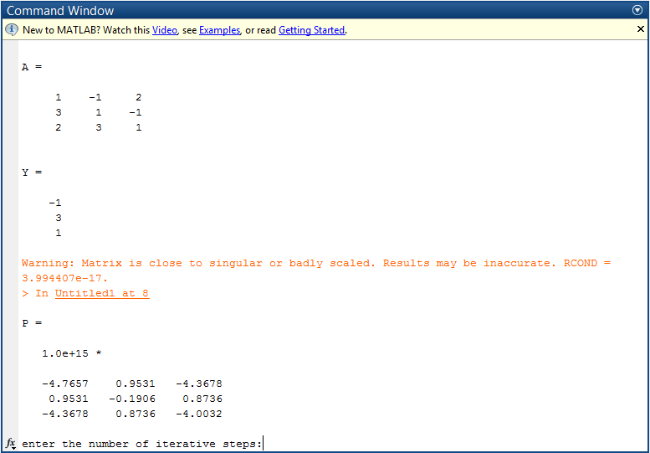

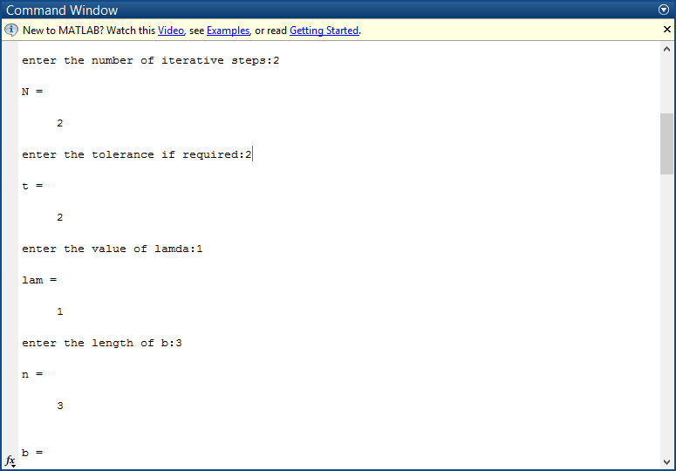

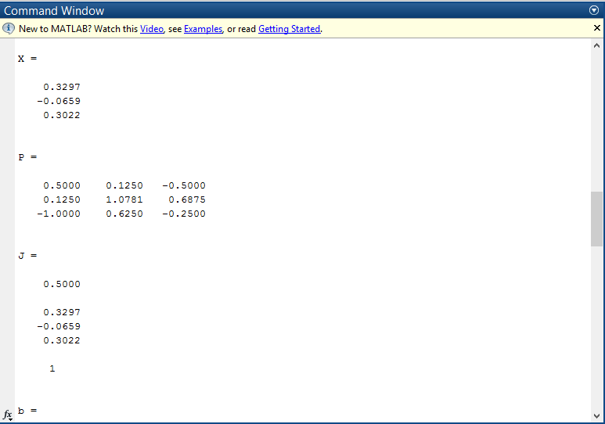

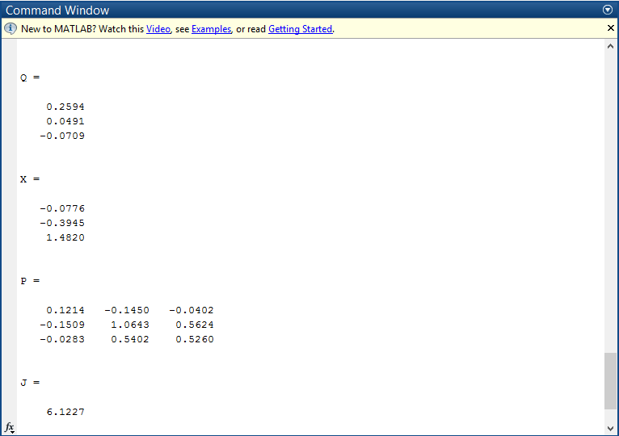

**Conclusion:**

We have presented the new method (NN-RLS) for solving special linear system

Of equations, such as Toeplitz, Vandermonder, Pascal, and Comrade systems etc. Since there are eﬃcient recursive least squares (RLS) for neural network, This algorithm may be useful. The results of above given examples in paper show that the NN-RLS method is very simple and eﬀective.

**Referances:**

1. A Neural-network Method Based on RLS Algorithm for Solving Special Linear Systems of Equations Zhezhao ZENG 1, Yuxiang TU 2 , Jinjin XIAO 1

2. Proceedings Article Recursive least-squares learning algorithms for neural networks

Paul S. Lewis ; Jenq N. Hwang [+] Author Affiliations.

3. Mahmood R. Azimi-Sadjadi and Ren-Jean Liou Fast Learning Process of Multilayer Neural Networks Using Recursive Least Squares

4.Regression with Matrix Algebra,http://faculty.cas.usf.edu/mbrannick/regression/regma.htm